| Cybersecurity |
| --- |
| Project 1 Technical Brief |

Make a copy of this document before you begin. Place your answers below   
each question. This completed document will be your deliverable for Project 1. Submit it through Canvas when you’re finished with the project at the end of the week.

## Your Web Application

Enter the URL for the web application that you created:

<https://anthonysecurityresume.azurewebsites.net/>

| [ebsites.net/](https://anthonysecurityresume.azurewebsites.net/) |
| --- |

Paste screenshots of your website created (Be sure to include your blog posts):

|  |
| --- |

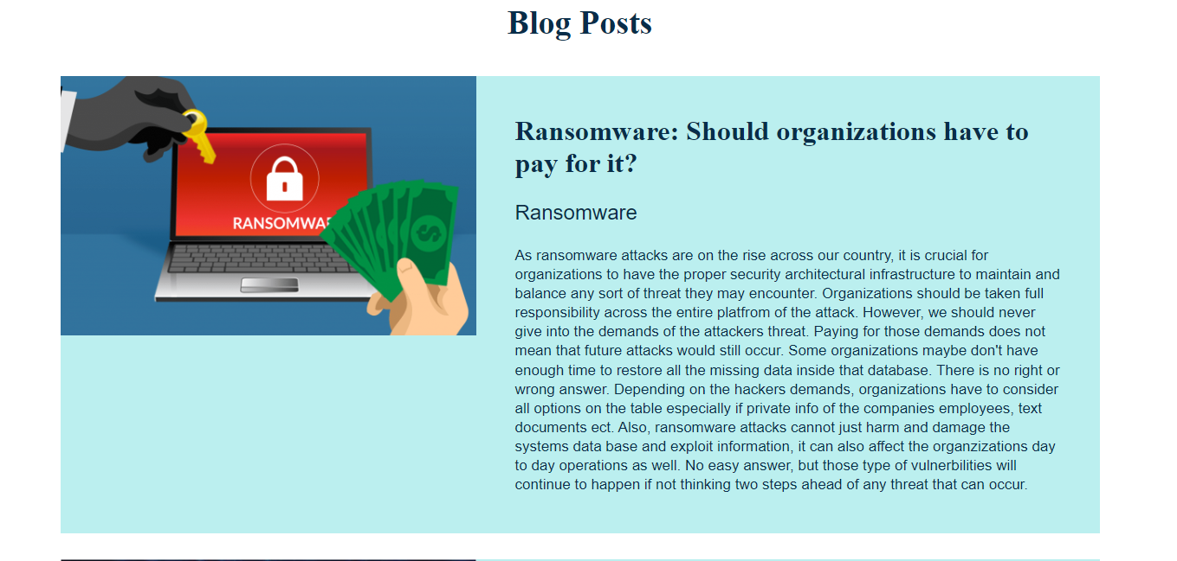

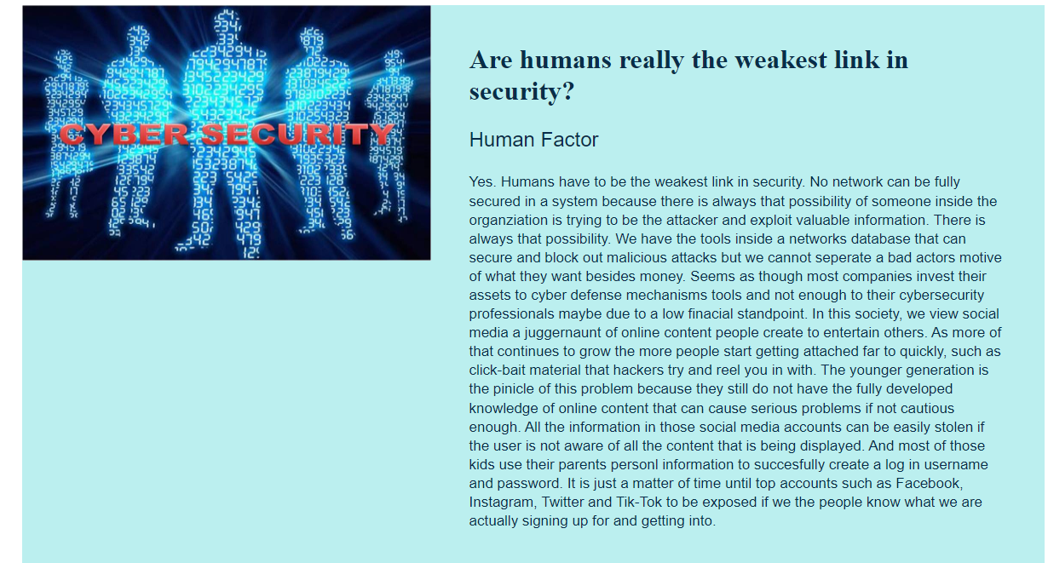

## Day 1 Questions

### General Questions

1. What option did you select for your domain (Azure free domain, GoDaddy domain)?

| Azure Free domain |
| --- |

1. What is your domain name?

| *Should be “blog” not resume..*  Anthonysecurityresume.azurewebsites.net |
| --- |

### Networking Questions

1. What is the IP address of your webpage?

| 20.119.0.23 |
| --- |

1. What is the location (city, state, country) of your IP address?

| Washington,Virginia USA |
| --- |

1. Run a DNS lookup on your website. What does the NS record show?

| anthony [ ~ ]$ nslookup anthonysecurityresume.azurewebsites.net  Server: 168.63.129.16  Address: 168.63.129.16#53  Non-authoritative answer:  anthonysecurityresume.azurewebsites.net canonical name = waws-prod-blu-373.sip.azurewebsites.windows.net.  waws-prod-blu-373.sip.azurewebsites.windows.net canonical name = waws-prod-blu-373-0ed5.eastus.cloudapp.azure.com.  Name: waws-prod-blu-373-0ed5.eastus.cloudapp.azure.com  Address: 20.119.0.23  anthony [ ~ ]$ |
| --- |

### Web Development Questions

1. When creating your web app, you selected a runtime stack. What was it? Does it work on the front end or the back end?

| PHP 8.0, yes back end |
| --- |

1. Inside the /var/www/html directory, there was another directory called assets. Explain what was inside that directory.

| The css assets, which hels design and edit your web app |
| --- |

1. Consider your response to the above question. Does this work with the front end or back end?

| Front end |
| --- |

## Day 2 Questions

### Cloud Questions

1. What is a cloud tenant?

| Where info is gathered in an organization that connects with any sort of group, user, device within platforms such as Microsoft 365. |
| --- |

1. Why would an access policy be important on a key vault?

| Because specific users and groups can have access to that key fault and not unauthorized users. |
| --- |

1. Within the key vault, what are the differences between keys, secrets, and certificates?

| Keys are used to encrypt messages that won’t expose the private key. Secrets manage the storage size from the data that is being encrypted. |
| --- |

### Cryptography Questions

1. What are the advantages of a self-signed certificate?

| An easier way to design and develop networks that are being tested inside a website. They store more data. |
| --- |

1. What are the disadvantages of a self-signed certificate?

| Unable to identify the actual user. |
| --- |

1. What is a wildcard certificate?

| With the wildcard symbol * helps maintain more than one domain in the certificate. |
| --- |

1. When binding a certificate to your website, Azure only provides TLS versions 1.0, 1.1, and 1.2. Explain why SSL 3.0 isn’t provided.

| Because SSL 3.0 would be suspect and wouldn’t protect the person’s information, therefore microsoft azure got rid of it. |
| --- |

1. After completing the Day 2 activities, view your SSL certificate and answer the following questions:
   1. Is your browser returning an error for your SSL certificate? Why or why not?

| No because my SSL certificate was created on my web application site. If it cannot verify the root user, the error message will pop up. |
| --- |

* 1. What is the validity of your certificate (date range)?

| 3/3/24, 9:05:55 PM CST - 3/9/23, 9:05:55 PM CST |
| --- |

* 1. Do you have an intermediate certificate? If so, what is it?

| No |
| --- |

* 1. Do you have a root certificate? If so, what is it?

| Yes, DigiCert Global Root G2 |
| --- |

* 1. Does your browser have the root certificate in its root store?

| Yes |
| --- |

* 1. List one other root CA in your browser’s root store.

| Microsoft Azure TLS issuing CA |
| --- |

## Day 3 Questions

### Cloud Security Questions

1. What are the similarities and differences between Azure Web Application Gateway and Azure Front Door?

| Similarities- Both primary solution is a load balancer. Both reside in front of your web application in order to protect it.  Differences- Azure front door is more global and better suited when you have a variety of regions in a cloud environment. Gateway is more regional and works better in a single region of the cloud. |
| --- |

1. A feature of the Web Application Gateway and Front Door is “SSL Offloading.” What is SSL offloading? What are its benefits?

| Process of downsizing the load of the web servers so that SSL encryption and decryption can be moved to more of a secured server and take weight off the load balancer. |
| --- |

1. What OSI layer does a WAF work on?

| Layer 7 Application |
| --- |

1. Select one of the WAF managed rules (e.g., directory traversal, SQL injection, etc.), and define it.

| SQL injection is a type of web application attack intended to manipulate queries so that an attacker can use a database in ways the developers did not originally intend. |
| --- |

1. Consider the rule that you selected. Could your website (as it is currently designed) be impacted by this vulnerability if Front Door wasn’t enabled? Why or why not?

| Yes because then the attacker could maintain access to my database and extract data info and files. |
| --- |

1. Hypothetically, say that you create a custom WAF rule to block all traffic from Canada. Does that mean that anyone who resides in Canada would not be able to access your website? Why or why not?

| They would not have access because of the rules I created, unless the person in Canada is using a VPN to try and get in. |
| --- |

1. Include screenshots below to demonstrate that your web app has the following:
   1. Azure Front Door enabled

| Answer below |
| --- |

* 1. A WAF 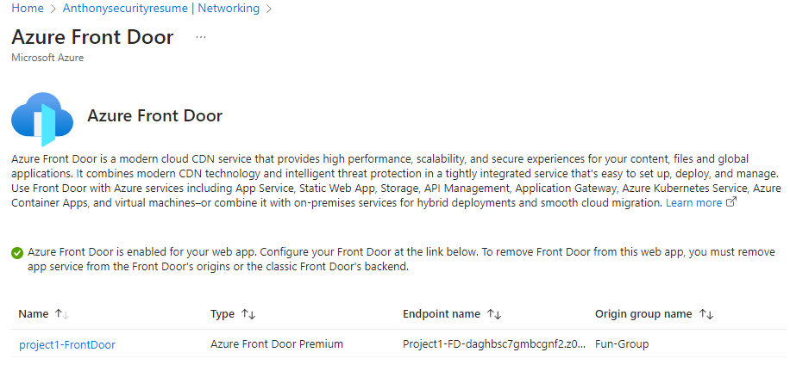custom rule

|  |
| --- |

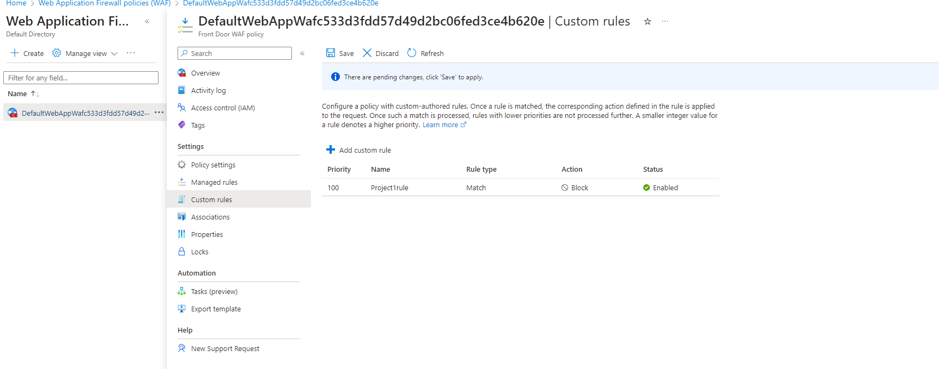

## Disclaimer on Future Charges

Please type “**YES**” after one of the following options:

* ***Maintaining website after project conclusion****: I am aware that I am responsible for any charges that I incur by maintaining my website. I have reviewed the* [*guidance*](https://docs.google.com/document/d/1ZzC4oTJFdlkkeWuzuJAyVSqtDFbuAWilmwXg8PZgzMs/edit) *for minimizing costs and monitoring Azure charges.*

* ***Disabling website after project conclusion****: I am aware that I am responsible for deleting all of my project resources as soon as I have gathered all of my web application screen shots and completed this document. YES*

© 2022 Trilogy Education Services, a 2U, Inc. brand. All Rights Reserved.